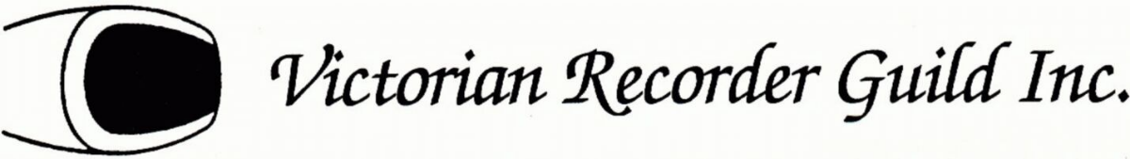

8 FOOT/ LOW RECORDER WORKSHOP

Saturday 25th October 11.00am to 4.00pm

Venue: Room 3, Hawthorn Library, 584 Glenferrie Road, Hawthorn

We are delighted to welcome Robyn Mellor for this year’s low recorder workshop. Robyn is a Canberra based recorder player, community based music director and teacher and will be known to those who attended the Australasian Recorder Festival at Armidale earlier this year.

The workshop for tenor, bass, great bass, contra bass and anything lower will run for a full day with a break for lunch (BYO).

Booking Form is due back by Saturday 11th October.

----------------------------------------------------------------------------------------------------

Name …………………………………………………………………….

Email………………………………….… Phone……………………………….

Instrument/s you will be playing…………………………………………………

Fee $45 Members $55 Non-members

Tea and coffee will be provided but you will need to bring your own lunch.There is carparking alongside and behind the library. Public transport – By rail - Glenferrie station on the Lilydale line OR by tram -Tram Route 75 departs from Flinders Street, stop 32 Riversdale Road.

---------------------------------------------------------------------------------------------------------

Payment may be made by direct deposit to Victorian Recorder Guild, BSB 063 113, Account 10084383 with payment code LR + your family name + initial (eg LRJonesL)

Amount payable………………………… Date of your deposit……………………

Form maybe scanned and sent to [sujlyons52@outlook.com](mailto:sujlyons52@outlook.com) or alternatively

form (and cheque if used $………….payable to Victorian Recorder Guild)

to 4/90 Herbert Street, Mornington by 11th October.